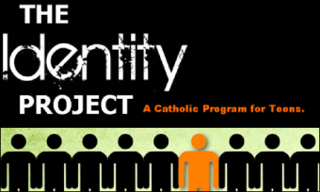
Who am I? What am I looking for? The Identity Project can lead you to answers
and YOU decide where to start looking.
What is it? The Identity Project is comprehensive Catholic formation for teens in Evansville and surrounding communities that allows them to choose topics that most interest them. More than “religious ed” – anyone can participate – whether they are in Catholic school, public school, home school, or are already active in their own home parish programs. Everyone is invited.
And it’s flexible.
We know you’re busy. So the Identity Project meets for 2 hours one to two times a month, leaving lots more time for all your family and school commitments.

What do I do next?
Sign up with your parish DRE or Youth Minister by October 1st. There is a signup form, diocesan waiver, and medical form. Fees are determined by individual parish policies. Don’t forget to choose your topic!
Here’s what we’re offering this year (topics rotate every 4 years):
Credible Catholic – Have you ever wondered if God exists? What evidence is there for the soul? Why does suffering exist? What is happiness? Join us for this stimulating series on the Catholic Faith and its relationship with science and reason as we explore the scientific and philosophical evidence that addresses these questions and more!
Launch for Life – Are you ready for life after high school? Join us in this engaging study to discover who you are in Christ and how to practically apply His principles to daily life, including how to live debt free, pursue a meaningful career, achieve your goals, and set yourself up for a fulfilling future.

Dates & Times: Sundays 1:00-3:00pm – social time begins at 12:45 at Holy Redeemer, 918 W Mill Rd., Evansville
October 14
November 11
December 9
January 6
January 20
February 10
February 24
March 10
March 17
April 7
April 28
For more info, contact Identity Project Coordinator, Renee Kast, at (812) 305-5397 and rkast@evdio.org, or contact your parish DRE or Youth Minister.

